CONDITIONAL EXECUTION

The If Statement

A Boolean expression is a logical statement that is either TRUE or FALSE. Boolean expressions can compare data of any type as long as both parts of the expression have the same basic data type. You can test data to see if it is equal to, greater than, or less than other data.
The simplest form is the if statement, which has the general form:
if BOOLEAN EXPRESSION:
STATEMENTS

A few important things to note about if statements:
- The colon (:) is significant and required. It separates the header of the compound statement from the body.
- The line after the colon must be indented. It is standard in Python to use four spaces for indenting.
- All lines indented the same amount after the colon will be executed whenever the BOOLEAN_EXPRESSION is true.
Here is an example:
food = 'spam'

if food == 'spam':
print('Ummmm, my favorite!')
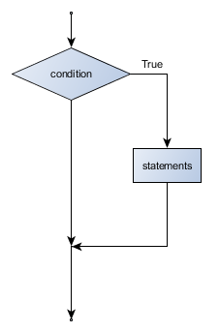
An If Statement flowchart -
The If-Else Statement

The syntax for an if else statement looks like this:
if BOOLEAN EXPRESSION:
STATEMENTS_1 # executed if condition evaluates to True
else:
STATEMENTS_2 # executed if condition evaluates to False

Here is an example:
if food == 'spam':
print('Ummmm, my favorite!')
else:
print("No, I won't have it. I want spam!"
Flowchart:
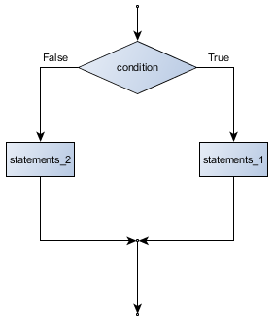

Chained Conditionals
Sometimes there are more than two possibilities and we need more than two branches. One way to express a computation like that is a chained conditional:
if x < y:
STATEMENTS_A
elif x > y:
STATEMENTS_B
else:
STATEMENTS_C

Here is an example:
if choice == 'a':
print("You chose 'a'.")
elif choice == 'b':
print("You chose 'b'.")
elif choice == 'c':
print("You chose 'c'.")
else:
print("Invalid choice.")
Flowchart:
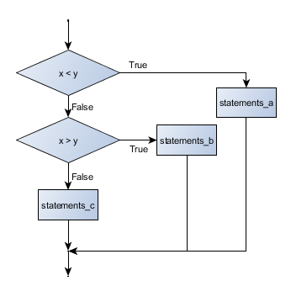

Nested Conditionals
One conditional can also be nested within another. (It is the same theme of composibility, again!) We could have written the previous example as follows:
Flowchart:
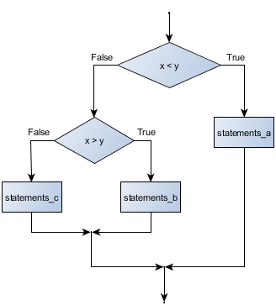
if x < y:
STATEMENTS_A
else:
if x > y:
STATEMENTS_B
else:
STATEMENTS_C
The outer conditional contains two branches. The second branch contains another if statement, which has two branches of its own. Those two branches could contain conditional statements as well.
Although the indentation of the statements makes the structure apparent, nested conditionals very quickly become difficult to read. In general, it is a good idea to avoid them when you can.
Logical operators often provide a way to simplify nested conditional statements. For example, we can rewrite the following code using a single conditional:

if 0 < x: # assume x is an int here
if x < 10:
print("x is a positive single digit.")
The print function is called only if we make it past both the conditionals, so we can use the and operator:
if 0 < x and x < 10:
print("x is a positive single digit.")

Assignment

Question:
Generate a random number (a good programmer uses Google effectively) which is greater than 0 and less than 21. Print “The number _your_random_number_ is odd” if the generated number is odd, and “The number _your_random_number_ is even” if the generated number is even.
Submit your solution by pasting your code on a Paste Service. Use https://pastebin.ubuntu.com/
This way we get to know that you are not just liking posts but also reading them.
For pastebin, use these values:
Poster – Conditionals Assignment
Syntax – Python3
Submit it and paste the link in the comment section of the Facebook post.

